Czech-Austrian Winter and Summer School

The situation, the potential and the future of hydro-power in the EU especially in Austria and the Czech Republic

Co-operating Universities



Financial support by

Ainedter Stefanie
Krainz Lisa
Malý Vítězslav

Prague and Vienna, 2009

Index
Index 0
Index of Tables and Figures 1
Abstract 2
1. The environmental situation of hydro power 3
1.1. European Union 3
1.2. Austria 4
1.3. The Czech Republic 5
2. The current situation of hydro power 5
2.1. European Union 5
2.2. Austria 7
2.3. The Czech Republic 11
3. The technologies of hydro power 14
3.1. Hydropower plant 14
3.1.1. Large hydropower plants 15
3.1.2. Small hydropower plants 16
3.1.3. Pumped-storage power plants 17
3.1.4. Tidal hydropower plants 17
4. The potential of hydro power for the future 17
4.1. European Union 18
4.2. Austria 19
4.3. The Czech Republic 21
5. Conclusion and what we can learn about hydropower for the future 23
References 25

Index of Tables and Figures

Figure 1: Share of each resource in the renewable primary energy production in EU in 2006 5
Figure 2: Share of each resource in the renewable primary energy consumption and share of each resource in the renewable electricity generation in the EU in 2007 6
Figure 3: Total energy supply in Austria from 2000-2007 7
Figure 4: Share of total primary energy supply in Austria, 2006 7
Figure 5: Electricity generation by fuel in Austria 8
Figure 6: The power plant fleet in Austria (2006) 9
Figure 7: Electricity network of Austria 10
Figure 8: RES, CZ 2007 11
Figure 9: Electricity generation by fuel, CZ 2006 12
Figure 10: Hydro power, installed capacity up to 1 MW 13
Figure 11: Share of RES in total electricity generation 14
Figure 12: World map with countries resized relative to hydro power potential 18
Figure 13: Estimated hydropower development by region 19
Figure 14: Compilation of the techno-economic total potential and its use 20
Figure 15: The distribution of the techno-economic potential in the federal states of Austria 21
Figure 16: Four fields for improvement to solve the energy problem 24

Tabel 1: Useful potential of hydropower in the Czech Republic 22
Tabel 2: Expected average production of electricity in Hydro power by year 2030 (in TWh) 22

Abstract
Hydro power is a renewable source of energy. This makes it an effective instrument against climate change. It produces electricity without emitting greenhouse gases. Hydro power is one of the best solutions to reach the 2020 targets. Thus we can reduce emission and raise the amount of renewable energy. As well hydro power plants produce no air pollutants.
Hydro power guarantees the independence of energy supply, because river water is a domestic resource and it is not subject to market fluctuations. Hydro power has many advantages like the high efficiency, of approximately 90 %.
These are just a few examples of the relevance of hydro power for the future energy supply. This is the reason why we have dealt with the topic.

This paper concerns following main question:
What can we learn for the future by comparing the situation of hydro-power in Austria and the Czech Republic and the overview of the situation in the European Union?
To occupy with this issue it is necessary to deal with the following sub questions further more:
- What is the environmental situation of hydro power?
- What is the current situation of hydro power?
- How much amount can be produced in the future and what is the potential of hydro power?
- Which technologies are used for hydro power plants?

We have to determine the potential of hydro power to know if we can solve the energy problems in the future with its help. With the data material of capacity, production and consumption of hydro power we tried to compare the situation in the European Countries, especially in Austria and the Czech Republic.

The situation is very different in the potential, the electricity generation and the consumption of the hydro power in Austria and in the Czech Republic.
The slope and the water capacity of rivers are basic proportion to use the hydro energy. Therefore the potential in Austria is very high compared to Czech potential which is too low to build large hydro power plants.
The electricity generation is related to the useful potential of rivers. Thereby Austria’s electricity generation is about 37,000 GWh per year and only 2,085 GWh per year in the Czech Republic. Total gross electricity production in 2007 amounted to 340,714 GWh in EU27 and 303,908 GWh in EU15.

Given these considerations, the future potential of hydro power varies in both countries widely. Austria’s electricity generation can be largely covered by hydro power but the Czech electricity generation has to be oriented either on fossil fuels or on nuclear power. For Europe we have to find the best renewable energy mix to reduce the amount of greenhouse gas emissions to fulfil the 2020 targets.

The environmental situation of hydro power
An overview about the ecological possibility to install hydro-power in several EU countries especially in Austria and the Czech Republic is for the whole paper very important. Therefore the first chapter outlines the environmental situation of hydro power in the European Union, in Austria and the Czech Republic.

European Union
“There is no doubt hydropower can play a significant role in meeting many environmental goals, including climate change. In our increasingly carbon-constrained world, renewable energy forms, such as hydro power, have the potential to meet the sustainability criteria demanded of our times.” said Stéphane Dion, Chair of UNFCCC COP11 and Canadian Environment Minister in 2005.
That’s the reason why hydropower is so important and should be developed where it is possible.
Like most other renewable, hydropower is indirect solar power. It is also a flow power which adds up to an annual energy contribution over a year. Precipitation (rain or snow) on high land leads to potentially high available energy. Not in every European country are the same geological requirements. At least we need water to install a hydro power plant. Consequently countries with many rivers, seas and mountains are preferred. But the rain has to fall on hills or mountains to let the water flow.
The environmental effects of hydropower projects, particularly one involving a dam and reservoir, are significant and must be taken into account when a project is under construction.
The hydrological effects are mostly ecological and affect water flow, groundwater, water supply and water quality. The installation of hydro power plants has consequences on the rearranging of resources like diverting a river into a canal or a mountain stream into a pipe. Big dams and large reservoir can reduce the available water supply. While the dams are under construction it can affect the eco-system in the long term. Also the local fish population can be impacted if fish cannot pass the dams to the spawning grounds or to the ocean.
But the positive impact of hydro power is that it is fuelled by water, so it's a clean fuel source. Hydropower doesn't pollute the air like power plants that burn fossil fuels, such as coal or natural gas.
Besides the environmental situation the social effects are enormous. On the one side the power plants can reduce the beauty of landscape and on the other side it can come to competitions with other uses for the land. But in Europe are mostly small power plants which don’t have that big impact on the society.

Austria
The utilization of hydro power is very important for economic aspects to achieve sustainability and the climate protection targets. Hydropower is the main source of renewable energy in Austria. Utilizing the power of hydro as a clean and emission-free way of generating electricity became a tradition in Austria decades ago.
The expansion of it is needed to achieve the targets for renewable energy. Furthermore hydropower is a domestic energy source, which can ensure the independency of the Austrian power supply.

The environmental situation
Austria is a country situated in Central Europe in the temperate climate zone.
It has the best topography conditions with high mountain ranges, the Alps and the temperate climate, for using hydropower .Almost two thirds of Austria’s surface are covered by alpine regions (mostly concentrated in the west and the south), which form a natural barrier to rain clouds and stimulate them to rain. These areas have a total annual precipitation of more than 1 000 mm per year. The eastern and northern parts by contrast are largely flat or gently sloping plains. In these areas the nation’s largest cities and the majority of the industry are located. These circumstances lead to the fact that the hydropower plants are disproportionately spread with the majority situated in the mountains.
Austria has rivers with a total length of 100,000 km.. Most rivers have a long slope so the energetic use of hydro power by the driving of turbines in hydraulic power stations and storage power plants can be used.
The main rivers in Austria that can be used for generating hydropower are the Rhine, Lech, Inn, Salzach, Danube, Enns, Mur and Drau.
Especially the river Danube plays an important role as a source for hydroelectricity. Austria has on the one hand cold winters and on the other hand warm summers, which causes seasonal variations in the energy demand and the power supply from the large share of hydropower plants in the country.

The Czech Republic
The large part of the Czech Republic consists of hilly landscape fringed with mountain chains (Krkonoše, Šumava, Jeseníky etc.). Rivers and streams by an overwhelming majority rise either in these mountain chains or in another hilly terrain (Českomoravská vrchovina, Brdy etc.). Therefore rivers are small and haven’t enough slope and water to supply large hydro power plants. For this reason natural conditions are unfavourable to construct hydro power plants, but in the context of renewable resources in the Czech Republic it still plays an important role.

The current situation of hydro power
Global energy use has risen by 70 % since 1971 and continues to increase at the rate of about 2 % per year. There are many scenarios for future demand and the energy mix that will be needed to meet this. Also because of the global warming and the atmospheric pollution we have to change from non-renewable resources to renewables. So we can reduce the pollution emitter like CO₂ or SO₂. Therefore the currant situation of hydro power will be described in this chapter.

European Union
Renewable energy represents approximately one-fifth of total power generation. Hydro power is the most advanced and flexible of the renewables and represents 87% of this production. The whole renewables portfolio for heat, power and transportation offers an enormous potential. At the moment only one-third of the realistic potential of hydro power has been developed.
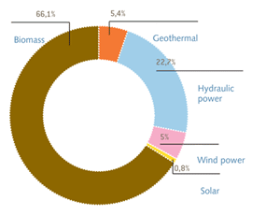
Figure 1: Share of each resource in the renewable primary energy production in EU in 2006
The upper figure shows that hydro power represented 22.7 % of the renewable primary energy production in the EU in 2006. In the following year 2007 the primary energy production of hydro power constituted 29.30 Mteo in the EU27 and 26.14 Mtoe in the EU15. For comparison the primary energy production in Austria was 5.58 Mtoe and in the Czech Republic only 0.22 Mtoe. Total gross electricity production in 2007 amounted to 340.71 TWh for EU27 and 303.91 TWh for EU15. One of the highest total gross electricity productions had Sweden with 66.05 TWh and France with 63.66 TWh. On the contrary the Czech Republic produces only 2.52 TWh and Austria 36.42 TWh.
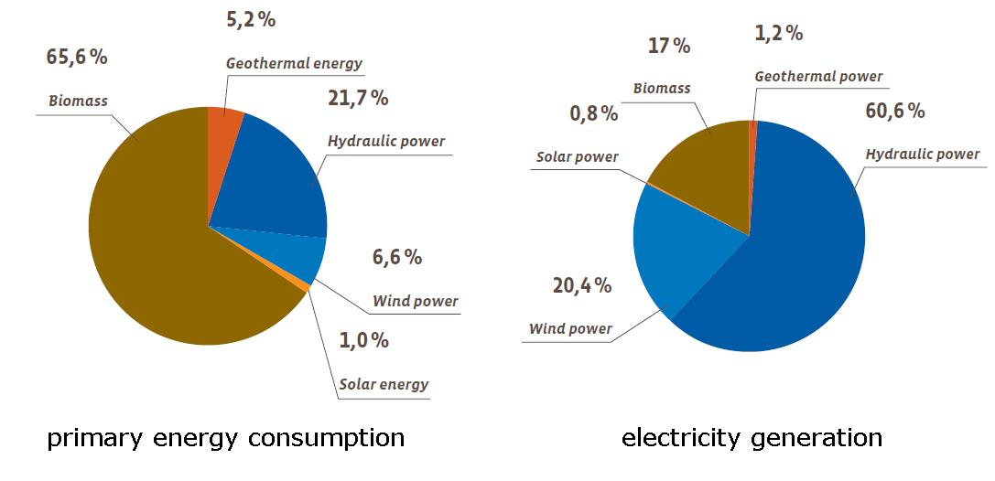
Figure 2: Share of each resource in the renewable primary energy consumption and share of each resource in the renewable electricity generation in the EU in 2007
The left graph Figure 2 shows the primary energy consumption of renewables in the EU in 2007. Renewable energy out of biomass and hydro power had the most consumption with two-thirds (65.6 %) of biomass followed by hydroelectricity with 21.7 %.
The share of each resource in the renewable electricity production is separated in hydro power, wind power, biomass, geothermal power and solar power. The right graph in Figure 2 shows that hydro power generates the most electricity with 60.6 % followed by wind with 20.4 % and biomass with 17 %.

About 7.53 % of the total energy consumption in EU27 is shared of renewable energies. Sweden is the number one of renewables consumption with 31.29 % followed by Latvia with 29.31 %. Austria with 23.41 % is on the third place, while the Czech Republic uses only 4.47 % renewables of energy consumption.
If we compare the share of total energy consumption with the share of renewables in gross electricity consumption of EU countries in 2007 the share of renewable electricity consumption is the double of total energy consumption with 14.93 %. Austria is on the first place with 54.80 %, followed by Sweden with 52.09 % and Latvia with 35.98 %. The Czech Republic consumes only 4.65 % electricity of renewable energy.

As we can see from the data above, Europe covers a high amount of it`s renewable energy production out of hydropower and biomass. Actually hydro power is the most important renewable electricity production in the European Union. In general the electricity consumption of renewables is potentially higher than the energy consumption of renewables.

Austria
As shown in the figure below, the total energy supply in Austria rose in the years from 2000 to 2007 from 1,222 PJ to 1,421 PJ.
In PJ
Figure 3: Total energy supply in Austria from 2000-2007
The share of hydropower is about 8.9% of the total primary energy supply in Austria in the year 2006 (as shown in the figure below).
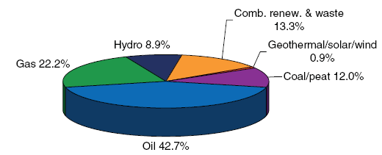
Figure 4: Share of total primary energy supply in Austria, 2006
The share of renewable energy in Austria is traditionally high compared to other European countries.
Even if the use of hydropower is caused by the weather and fluctuates seasonally, the share of renewable energy of the total energy supply has been constantly over 20% since the beginning of the eighties. The highest percentage derived from the years 1999 and 2000 with a percentage of over 23%.
Hydropower is a very important source in producing electrical energy. It is quantitative the main renewable energy source in Austria.
The entire production out of renewable energies (compare figure below) grew from about 34 TWh in 1990 to about 40 TWh in 2002, while the output of renewables in 2005 only amounted to 32 TWh. The installed large hydro capacity only rose by 0.6 GW during this period.
Correspondingly, in spite of a growing small hydro capacity (816 MW in 1990 to 960 MW in 2003) the electricity generated from small hydro (4.0 TWh in 1990 to 3.6 TWh in 2005) declined.
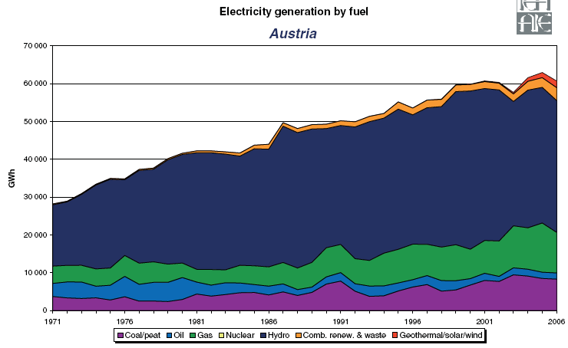
Figure 5: Electricity generation by fuel in Austria

As shown in the figure below in 2006 2,441 hydropower plants in Austria were registered and produced about 37,278 GWh power. 25,905 GWh came from run-of-river power stations 11,174 GWh were produced from storage power stations and the remaining 199 GWh were produced from other small hydro power plants.
The major production of run-of-river power stations derives from the federal states Lower Austria and Upper Austria in the category storage power stations the federal state Tyrol is the major producer.

Power Plant Fleet in Austria
For the year 2006
Power plant type
 |  |  |  | Amount | generation  in GWh | total installed capacity in MW
Hydropower plant | run-of-river power stations | Up to 10 MW |  | 533 | 3,298 | 732
Hydropower plant | run-of-river power stations | beyond 10 MW |  | 87 | 22,607 | 4,449
Hydropower plant | Storage power stations | Up to 10 MW |  | 38 | 434 | 149
Hydropower plant | Storage power stations | Beyond 10 MW |  | 59 | 10,740 | 6,305
Hydropower plant | Other small hydro power plants |  |  | 1,724 | 199 | 218
Hydropower plant | Sum hydro power plants |  |  | 2,441 | 37,278 | 11,853
Figure 6: The power plant fleet in Austria (2006)

The figure below presents the position of the power plants of Austria with a bottleneck capacity ≥ 5 MW from the year 2002.
In addition to a large number of run-of-river power stations the most important of them as the figure shows are located on the Danube, many storage power stations were constructed in the western alpine regions mainly covering peak loads and the electricity demand during the winter months. During the summer months the complete demand could hypothetically be covered by hydropower stations in practice, however, peaks generated in storage power stations are partly exported and base loads partly covered by thermal power stations.

Figure 7: Electricity network of Austria

In Kaprun is located a storage power station that was the first large-scale power station that was built after World War Two and it was celebrated as a symbol of reconstruction and progress.
At the early stage of hydropower construction attention focused on the technical aspects.
In the course of the last years environment protection started to become important and any further expansion is now only possible if strict environmental standards are observed.

In addition to the large-scale hydropower stations of energy supply enterprises numerous small and smallest-scale stations are working in Austria. A power station is classified as a smallscale if its bottleneck capacity is up to 10 MW. In Austria 533 smallscale run-of-river hydropower stations, 38 smallscale Storage power stations and 1,724 other small hydro power stations with a bottleneck capacity beyond 1 MWh which can not be classified, are statistically included because they are connected to the public grid.

The Czech Republic
The current situation of RES
The production of electricity from renewable sources has been an important technical and political issue since the seventies of the last century and it has received a new dimension after joining the European Union. In the Czech Republic was produced only 4.7% of total energy consumption from renewable sources in 2007, but it committed itself to produce 8 % of the total electricity gross national consumption from renewable energy sources in 2010.
Figure 8: RES, CZ 2007

The Czech Republic has consumed 1908,4 PJ primary energy sources in 2007 while the consume is making an increasing trend in recent years. Electricity generation in the Czech Republic is found largely on coal and nuclear energy which it provide an estimated 52% and 32% respectively of generated electricity. The share of oil is very small, but gas is making a growing contribution to power generation in recent years.
The decisive factor determining the level of renewable energy consumption in the Czech Republic is biomass, which it is used either in industry or in households and it has comprised together 81,8% of renewable energy sources. Hydropower contributes to the total renewable energy sources with only 8.2%.

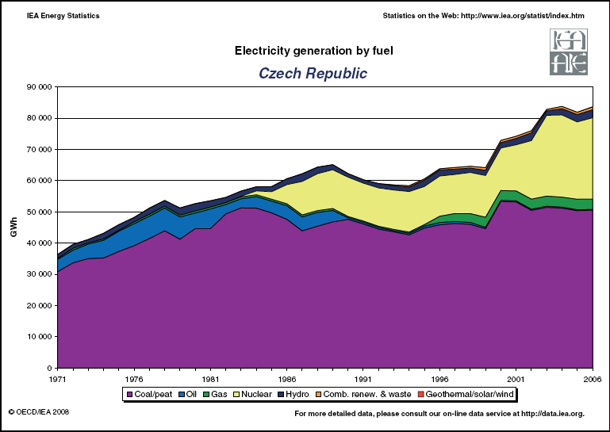
Figure 9: Electricity generation by fuel, CZ 2006

The current situation of hydro power
In the Czech Republic is the use of water power long tradition. The oldest construction was hydropower plant in Písek for the production of electricity, which was built in 1888. This work was constructed following the great success promotional lighting the city center by František Křižík 23rd June 1887 and Pisek became the first Czech city with standing public electric lighting. Also in Prague existed two hydropower plants - Těšnov and Štvanice in the early 20th century. Hydro powerplant Těšnov was repealed in 1929, after reconstruction Štvanice is still in serviceable condition.
After the 1.World War hydropower plants, especially the small one, started to be built very often and in the Czech Republic were about 11 000 small hydropower plants in thirties of last century which it have been connected with factories and it produced electricity for them.
During the Communistic era the government began to built large hydro power plants (Lipno, Orlík, Slapy, etc.), which were considered to be economically more efficient than the small one which it ceased to be on the ground to support and built. For these reasons only 135 small hydropower plants with a total installed capacity of 10 MW hours were on the territory of Czech Republic in 1981. On the other hand the government have been started to support the reconstruction of small hydro since the half of eighties because of the great deficit of power.
Currently 1398 hydropower plants is located in the Czech Republic, 8 large hydropower plants and 1390 small hydropower plant. Hydropower plants have produced 2,11 TWh of electricity with total installed capacity 2 176 MW in the previous year. Problem is that power generation depends on annual precipitation, therefore it should be strictly related to given year. For example hydro power has produced 2,55 TWh in the previous year. In the production of electricity hydropower plants have largest share of all renewable sources but in the total generation of electricity the share of production is quite low, only 2.9%.
The Czech Republic ranks among countries with low levels of electricity generation by hydropower plants in the Europe, it has only 350 kWh/ha and this number will be probably also definitive, as the majority of water potential in our country has been already used.

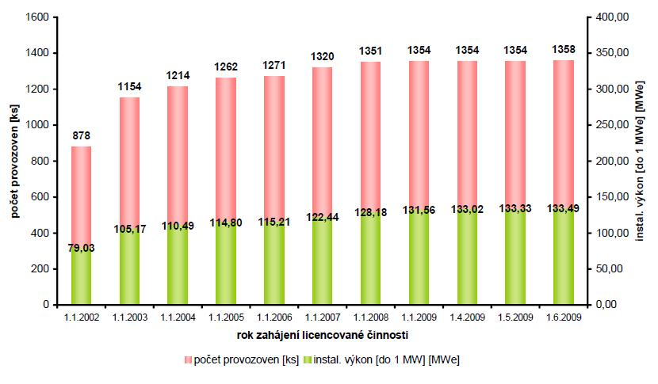
Figure 10: Hydro power, installed capacity up to 1 MW

The main function of hydropower plant in the Czech Republic is serving as a supplementary source of electricity generation and it is used mainly itself ability to carry out rapid starting with a high-performance and therefore it is highly used in operating equalization of energy supply when is energy consumption on the peak.
Hydropower plants have a many other important goals for which it was built. Among these aims belongs the ensuring of floods possibilities, fishing, supply of water for towns and villages, recreation and many other water features.

Figure 11: Share of RES in total electricity generation

The technologies of hydro power
A hydro power plant generates electricity with the force of moving water when it passes through hydraulic turbines. There are several types (run-of-river, storage, pumped storage) and scales of hydro power plants (small, medium and large).
The operational flexibility of hydropower schemes can provide a range of power services: storage schemes to follow peak demands for power, while run-of-river schemes provide the backbone of supply, or ‘base load’.
Storage hydro (including pumped-storage) can improve the performance of conventional thermal power plants. In mixed energy systems, storage hydropower can follow rapid changes in demand, allowing conventional plants, including nuclear stations, to operate at their optimum steady state. In the case of fossil-fuel schemes, this reduces both fuel consumption and associated emissions.
Small hydro power is usually 10 MW or less in size. It is normally run-of-river design and is one of the most environmentally caring energy conversion options available, because it does not attempt to interfere significantly with river flows.
The following subchapter contains more details about different plants on the examples of hydropower plants of the Czech Republic.

Hydropower plant
Depending on its size and type can be hydropower plant divided into 4 groups:
- Large Hydropower plant (over 10 MW)
- Small hydropower plant (up to 10 MW)
- Pumped-storage power plant
- Tidal hydropower plant

Large hydropower plants
Large hydropower plants are those which it have performance greater than 10 MW. In the Czech Republic 8 large hydropower plants are located with total installed capacity 736 MW. Most of them are situated on the river Vltava and it form together cascade which it is known as „Vltavská kaskáda“.

Lipno
Hydro power plant Lipno is situated on river Vltava on plateau in mountain chain Šumava and it was built mostly for water and energy purposes. Aim of construction was utilization of 160m slopeas source of top and controllable electric energy, ensuring of minimal flow in Vltava at altitude 6 m³s⁻¹, flood protection, influence of winter flow regime, improvement of hygienic conditions in Vltava under aquatic work, supply of water for village Loučovice and paper processing factory Loučovice and finally utilization of water reservoir for recreation, fishing and naval transport.
Dam reservoir is with its area 4 870 ha largest artificial lake in Czech Republic. It is located at latitude 726 above sea level and its volume is 306 mil. m³ of water with lenght 48 km.
This work is consists of two dams, artificial water reservoirs and two hydro plants called Lipno I and Lipno II. The construction of work was started at the year 1951 and the first hydro plant has started to work on August 13 1959, second set has started to work on January 5 1960. Lipno has original solution of aquatic work with power plant installed under ground cavern in depth of 160 m.
Hydro plant Lipno I is equipped with two sets each with output 60 MW, which are located in underground cavern of area 60 x 22 x 38 m. Water is brought to turbines by inlet object and two press shafts of diameter 4,5 m into room of stoppers. These stoppers bring water through 24 control blades into the Francis turbines. Each of turbines is firmly connected with generator, which reaches during maximal flow 46 m³s⁻¹ of water through turbine output 60 MW. Water which hands over its energy in turbine, outlets through waste tunnel to balance reservoir Lipno II at Vyšší Brod. River Vltava hasnť enough water to supply Lipno to keeping permanent high production of electricity, therefore hydro power plant is using only at peak hours during the day.
Dam is 296 m long and 25 m high. It is made on right side from two thirds of its length underground with caulk core, at left side is rest of dam made of concrete with two functional blocks. In these blocks are located two overflow fields, two outlets and extraction of industrial water. Dam is situated in river kilometre 329,543.
Aim of hydro plant II is to balance outlet from power plant Lipno I. It is flow hydro plant with one set, consisting of Kaplan turbine with maximal hold 20 m³s⁻¹ and generator with output 1,5 MW. Level regulation ensures steady water outlet under aquatic work. Dam long 224 m and high 11,5 m lies at river kilometre 319,108 and again is combined, partly underground and partly concrete gravitational. In concrete part of dam are located two overflows, gravel culvert and three saturation fields. Water reservoir volume 1,6 mil m³, area 12,4 ha and its altitude is 558 above sea level.

Small hydropower plants
As has been already mentioned small hydro power plants have a maximum installed capacity up to 10 MV according Czech legislation, but due to the EU legislation small hydro power plants are those which it has installed capacity only up to 5 MW. The large proportions (90%) of small hydro power plants have more power than 5 MW in the Czech Republic therefore it should not belong to the group of small hydropower plant according the EU legislation. For our work we will keep the Czech division of hydro power plants since vast majority of the data about Czech hydro power plants proceed from this sorting.

Small hydropower plants can be divided into 4 groups:
Industrial-hydropower plant: from 1 MW up to 10 MW
Public-hydropower plant: from 100 kW up to 1 MW
Micro-hydropower plant: from 35 kW up to 100 kW
Mobile-hydropower plant: up to 35 kW

Small hydropower plants are very important in exploit the potential of rivers in the Czech Republic, which it is mostly built in a places where the old mills or weir were situated. Currently 1390 small hydropower plants work in the Czech Republic with total installed capacity 279 MW.
The majority of small hydropower plants serve as a seasonal, since the flow rates at which they are set up volatile and highly dependent on weather and season. In spite of this fact, it is quite possible to predict plants production and therefore it does not require the regulation of the grid.

Les Království
Water dam Les Království is situated on the river Labe in eastern Bohemia near Dvůr Králové nad Labem. The construction began in 1910 but then it was suspended during the First World War and it was finally completed in 1919. Dam is protected technical monument since 1964. (Prýmek, 1999)
The main aim of construction was mitigation of flood possibilities, which it had caused damages under the dam every year. Among other objectives the dam include ensuring water supply for villages situated below the dam, ensuring a minimum flow in the river Labe below the water dam, electricity generation and other utilization such as fishing, recreation, etc.
Hydro power plant was built and put through to the dam in 1923. Originally was machinery fitted with two Francis turbines with performance 1 120 kW but after the general reconstruction of the entire hydro power plant in 2005 it has new Francis turbine with performance 2 120 kW. Average annual production is about 11 000 MWh. Dam is protected technical monument since 1964.

Pumped-storage power plants
These types of power plants run on principle of pumping water from a lower elevation reservior to a higher elevation when energy consumption is off-peak and the low-cost electric power is used to run the pumps. During periods of high electrical demand, the stored water is released through turbines and it is used to generating the electricity.
In the Czech Republic exists three pumped-storage power plants – Dlouhé stráně, Hydropower plant Dalešice and Hydropower plant Štěchovice with total installed capacity 1145 MW.

Dlouhé stráně
It consists of two elevation reservoirs and machinery. First reservoir is unique, because it is situated at the top of the mountain Dlouhé stráně at an altitude of 1,350 meters above sea level with total volume of the tank 2,719 mil. m³. Second reservoir is located on the river Deštná below the hydropower plant at an altitude 824 meters above sea level with total volume of the tank 3,405 m³. Engine room with two Francis turbines of performance 325 MW is located in the mountains’ underground. Total performance is 650 MW, therefore is Dlouhé stráně highest-powered hydropower plant in the Czech Republic.

Tidal hydropower plants
The tidal power is a type of hydropower plant that transforms the energy of tides into electricity or other useful forms of power.

The potential of hydro power for the future
Hydropower uses the natural power of water to generate electricity, mostly with the aid of river dams. Worldwide many countries are beginning to use their unused capacity. In general hydropower is known to be environmentally clean. But in most cases the resident population does not accept the disturbance of the landscape because of large dams and reservoirs.
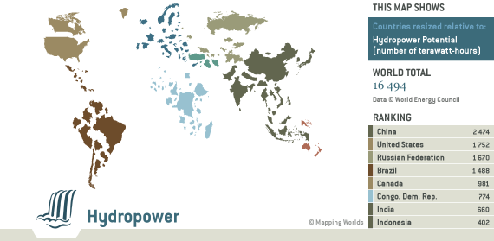
Figure 12: World map with countries resized relative to hydro power potential
The World map shows the size of the countries relative to their hydro power potential assessed in terawatt-hours. The highest potential can be identified for China (2.474 TWh), the United States (1752 TWh), Russian Federation (1670 TWh) and Brazil (1488 TWh). In Europe Turkey (216 TWh) and Norway (200 TWh) offer the highest amounts. In the European Union Italy with 105 TWh, France and Sweden with 100 TWh per country each and Austria with 75 TWh are the leaders of the hydro power potential. The Czech Republic is far behind with 4 TWh.

European Union
The world wide gross theoretical capability was calculated by the World Energy Council (WEC) with more than 41,202 TWh/a based on the end of 2005. Gross theoretical capability is the annual energy potentially available in the country or a region. It is based on the atmospheric precipitation and water run-off. The theoretical capability illustrates the supreme border of the hydro power plant potential.
The gross theoretical capability of Europe is around 4,945 TWh/a.
The worldwide technically exploitable potential was approximately more than 16,494 TWh/a, which is the amount of the gross theoretical capability that, can be exploited within the limits of current technology. For Europe it constitutes 2,714 TWh/a.

Figure 13: Estimated hydropower development by region
The upper Figure shows the technical feasibility, the current production and the realistic development of hydropower by region. Therefore the highest realistic development exists in Asia. Europe on the other hand has a quite high current production compared to its realistic development.

Austria
Pöyry energy worked on the techno-economic potential of hydropower by order of VEÖ, BMWA, E-Control, Kleinwasserkraft Österreich and VÖEW. The valuation of the technical efficient potenital is the potential of hydropower used in an technically possibile and economically senseful aspect.
As shown in the figure the study estimates a techno-economic potential of hydropower in Austria about 56,100 GWh. This techno-economic total potential has already been used in a dimension of 38,200 GWh.
techno-economic potential

Already used potential> 10 MW

Remaining potential
Already used potential < 10 MW

GWh
- Figure 14: Compilation of the techno-economic total potential and its use
With regard to this graph it becomes clear that a techno-economic potential of 18,000 GWh remains.
The calculated techno-economic remaining potenial considered only technical and economical aspects.
Today there are still high-sensitive areas (national park, Unesco Weltkulturereb - Wachau) that must be excluded from the calculated techno-economic remaining potential to reach the energetic potential which can be used for the hydro power - approximately. 13,000 GWh.

As showen in the figure the techno-economic remaining potential of 13,000 GWh and the already used potential can be disribiuted to the federal states of Austria following:
- Figure 15: The distribution of the techno-economic potential in the federal states of Austria
A relative high potential can still be used in the west of Austria (particularly in Tirol). The potential in Upper- and Lower- Austria is mostly exhausted and it remains a small techno-economic potential.
In fact, the enlargement of small hydro lagged far behind the potentials that are seen for this source in Austria – missing financial support is just one reason.

The Czech Republic
Since the hydrological potential of the Czech rivers is already largely recovered, the electricity generation will not be able to have a significant increase by hydropower plants in the future. For this reason, there will be only construction of small hydropower plants on the profiles, which the hydrotechnic conditions are significantly worse than the profiles where hydropower plants are already established. Therefore the investment costs will be higher than the costs of current hydropower plants.
The technical improvements act very important role in the prediction of the future electricity generation by hydropower plants. For large hydropower plants the technical progress would increase a performance up to 5%, for small hydropower plants the increase would be held from 10% to 15%. The reconstructed hydropower plants have increased absorption capacity and therefore the total installed capacity is higher. The problem is, that the Czech rivers haven’t enough water to supply the upgraded hydropower plants though the installed capacity will be higher, the count of hours will be lower when the hydropower plant would have generated electricity, totally it will be any increased of production in the Czech Republic.

 | GWh/year |  | MW | Number of power plants
Theoretical potential | 13 100
Useful potential | 2 565 | 100% | 1 125 | 1818
In PP above 10 MW | 1 165 | 45,4% | 736 | 8
In PP below 10 MW | 1 400 | 54,6% | 389 | 1810
Tapped potential | 2 085 | 81% | 1 015 | 1398
In PP above 10 MW | 1 165 | 100% | 736 | 8
In PP below 10 MW | 920 | 66% | 279 | 1390
Untapped potential | 480 | 19% | 110 | 420
In PP above 10 MW | 0 | 0 | 0 | 0
In PP below 10 MW | 480 | 34% | 110 | 420
Tabel 1: Useful potential of hydropower in the Czech Republic

According to a Government commission addressing the energy situation in the Czech Republic water potential of the Czech rivers is already used by 81% and the utilization should be approximately 97% of useful water potential in 2030. The Czech Republic should have produced 2,48 TWh per year in 2030.

year | 2007 | 2008 | 2009 | 2010 | 2011 | 2012 | 2013 | 2014 | 2015 | 2016 | 2017 | 2018 | 2019 | 2020 | 2030
LHPP | 1,17 | 1,17 | 1,17 | 1,17 | 1,17 | 1,17 | 1,17 | 1,17 | 1,17 | 1,17 | 1,17 | 1,17 | 1,17 | 1,17 | 1,17
SHPP | 0,94 | 0,95 | 0,95 | 0,97 | 1,00 | 1,01 | 1,02 | 1,04 | 1,08 | 1,11 | 1,14 | 1,18 | 1,24 | 1,26 | 1,32
total | 2,11 | 2,12 | 2,12 | 2,14 | 2,16 | 2,18 | 2,19 | 2,20 | 2,24 | 2,28 | 2,30 | 2,34 | 2,40 | 2,43 | 2,48
Tabel 2: Expected average production of electricity in Hydro power by year 2030 (in TWh)

Conclusion and what we can learn about hydropower for the future

To answer the question “What can we learn for the future by comparing the situation of hydro-power in Austria and the Czech Republic and the overview of the situation in the European Union?” it was necessary to research the environmental situation of the observed countries. The researched information showed that Austria compared to the Czech Republic has the better ecological conditions for installing hydropower plants. Although both countries are situated in the temperate climate zone and have no significant discrepance between their annual precipitation the possibility to use hydropower is diversed. The main resean for this variation based on the different topography. In Austria the condotions for hydropower are very good because of its high mountains and many rivers with the required slope. In comparison the Czech Republic has just hilly landscape fringed with mountain chains and small rivers with not enough slope for big hydropower plants. Generally in Europe are countries with better circumstances than others because of the high differences of the topography and climate conditions.

In the next step to answer the main question, it was important to evaluate the current situation of hydropower. In general 1/5 of the energy production in the EU is out of renewable energy resources. Therefrom hydropower is the second biggest renewable energy source behind biomass. In case of electricity generation hydropower has the highest share of all renewables, with around 60 %.
In Austria 20% of the total energy supply is produced by renewables. Hydropower is the most important renewable energy source for Austria. In the Czech Republic only less than 5 % of the total energy consumption is produced by hydropower.
In Austria renewable energy has a relative high share on the total energy production especially the electricity production of hydro power amounts to more than a half of the total electricity. Hydropower is the most important renewable energy source in Austria, compared to the Czech Republic, where hydropower belongs just to the third range of renewables.
The determine informations about the environmental and the current situation and the adequate technology provide a basis for the analysis of the hydropower potentials.

The future potential of hydro power varies in both countries widely.
The analysis of the potential shows that Austria’s electricity generation could rise 13,000 GWh (compared to a current generation of about 37,000 GWh), which means that Austria has already a great possibility to use hydropower to cover its demand. But the Czech electricity generation has to be oriented either on other possibilities (fossil fuels, nuclear power or a perfect mix of renewables). For Europe we have to find the best renewable energy mix to reduce the amount of greenhouse gas emissions to fulfil the 2020 targets.

As detected in the paper the situation of hydropower is very different in the potential, in the amount of the electricity generation and the consumption in Austria and in the Czech Republic.

To solve the energy problem hydropower is not the one and only solution. Europe-wide it depends on the country conditions if hydro power could be a part of the supply solution particularly for Austria the remainig hydro power potential offers possibilities. In other countries like the Czech Republic the potential of hydro power has little prospect for success.

Energy Efficiency
Technology
Renewable Energies
Behaviour Modification

Figure 16: Four fields for improvement to solve the energy problem

As shown in the upper figure there is more than one way to solve the energy problem. It has to be an interaction of energy efficiency, renewables, technologies, and behavior change.
First of all we have to reduce the dependency on fossil fuels and support the domestic energy sources. Also we have to find the adequate renewables, which depends on the circumstances of the several countries.
An important role in this case plays the technology. This presents a challenge to the governments to foster the development of new technologies in the energy sector (co-generation technologies and so on).

Besides the technologies and the different energy sources there are two more improvements: increasing of the energy efficiency and the behaviour modification.

References

Austrian Energy Agency, Daten über erneuerbare Energieträger in Österreich, 2006, http://www.energyagency.at/publ/pdf/res_dat06.pdf, 26.05.2009.

Boyle, Boyle Godfrey, Renewable Energy: Power for a sustainable future, Second Edition, Oxford University Press, Oxford, 2004

Breeze, Breeze Paul, Power Generation Technologies, Newnes, Burlington, 2005

Bundesministerium für Land- und Forstwirtschaft , Umwelt und Wasserwirtschaft, Wasser in Österreich- Zahlen und Fakten, 2000, www.http://gpool.lfrz.at/gpoolexport/media/file/Wasser_in_Oesterreich_-_Zahlen_und_Fakten_-_Folder_2007_Deutsch_020307.pdf, 25.05.2009.

Bundesministerium für Land- und Forstwirtschaft , Umwelt und Wasserwirtschaft, Wasser in Österreich – Zahlen und Fakten, 2007, http://gpool.lfrz.at/gpoolexport/media/file/Wasser_in_Oesterreich_-_Zahlen_und_Fakten_-_Folder_2007_Deutsch_020307.pdf, 03.06.09.

Business monitor international: Czech Republic power report, 2009, avaiable at: http://proquest.umi.com.ezproxy.vse.cz/pqdweb?index=25&did=1681150671&SrchMode=1&sid=1&Fmt=6&VInst=PROD&VType=PQD&RQT=309&VName=PQD&TS=1243956942&clientId=45149 (citation 2.6.2009) (BMI, 2009)

ČEZ: Vodní elektrárna Lipno, 2000, available at: http://www.ckrumlov.cz/cz1250/region/soucas/t_eleli.htm (citation 20.5.2009) (ČEZ, 2000)

CEZ: Les Království, 2009, avaiable at: http://www.cez.cz/cs/energie-a-zivotni-prostredi/energie-z-obnovitelnych-zdroju/voda/les-kralovstvi.html (citation 20.5.2009) (CEZ, 2009)

ČEZ: Obnovitelné zdroje energie a možnosti jejich uplatnění v ČR, Praha 2007, available at: http://www2.zf.jcu.cz/~moudry/databaze/pdf/Obnovitelne_zdroje_v_CR.pdf

DUŠIČKA, Peter a kol.: Malé vodní elektrárny, 1. vydání, Bratislava, Jaga group 2003, ISBN 80-88905-45-1 (Dušička, 2003).

EERE, Energy Efficiency and Renewable Energy, Advantages and Disadvantages of Hydropower, http://www1.eere.energy.gov/windandhydro/hydro_ad.html 21.05.2009

Energieverwertungsagentur- the Austrian Energy Agency, Renewable energy in Austria, 2003, http://www.energyagency.at/(de)/publ/pdf/ren_in_a_en.pdf, 30.05.2009.

ERU: Roční zpráva, 2007: available at: http://www.eru.cz/user_data/files/statistika_elektro/rocni_zprava/2007/index.htm , 16.6.2009

European Commission, RENEWABLE ENERGY COUNTRY PROFILES, 2008, http://ec.europa.eu/energy/renewables/doc/progress_country_profiles_february_2008_final.pdf, 16.06.2009.

EurObserv'ER, The state of renewable energies in Europe, 8th EurObserv’ER Report, 2008, http://www.eurobserv-er.org/pdf/barobilan8.pdf 20.05.2009

IEA: Total primaty energy supply, 2008, avaiable at: http://www.iea.org/textbase/stats/pdf_graphs/CZTPES.pdf (citation 2.6.2009) (IEA,2008)

IHA, International Hydropower Association, The contribution of hydropower, 2005, http://www.hydropower.org/downloads/F1_The_Contribution_of_Hydropower.pdf 20.05.2009

International Energy Agency: Energy Policies of IEA Countries: Austria 2002 Review, 2003 http://www.iea.org/textbase/nppdf/free/2000/austria2002.pdf, 05.05.2009.

Nezávislá komise pro posouzení energetických potřeb ČR v dlouhodobém časovém horizontu: Zpráva, 2008, Prague, available at: http://www.vlada.cz/assets/ppov/nezavisla-energeticka-komise/aktuality/zpravanek081122.pdf (Komise, 2008)

Pöyry Energy GmbH, Wasserkraftpotentialstudie, 2008, http://www.veoe.at/fileadmin/allgemein/PDF/06_2008_Wasserkraftpotenzialstudie_Langversion.pdf, 24.05.2009.

Povodí Labe: Přehrada Les Království, 2001, avaiable at: http://www.pla.cz/planet/public/vodnidila/prehrada_leskralovstvi.htm (citation 20.5.2009) (Povodí Labe, 2001)

Prýmek L.: Přehrada Les Království, 1999, avaiable at: http://www.interregion.cz/turistika/stavby/technika/les_kralovstvi/prehrada_les_kralovstvi.htm (citation 20.5.2009) (Prýmek, 1999)

Řeznicek: Malá vodní elektrárna Spálov, 2006 available at: http://www.issnp.cz/pdf/reznicek_enersol/spalov.pdf, 16.6.2009

Říha R.: Přečerpávací vodní elektrárny Dalešice a Dalouhé stráně, 2008, available at: http://www.gymnzidlo.cz/supl/114.pdf (citation 29.5.2009) (Říha, 2008)

Šauer P. Dvořák A.: Incentives for renewable energy sources in the Czech Rebublic, avaiable at: http://envigogika.cuni.cz/index.php/en/inspirations/20073/147-incentives-for-renewable-energy-sources-in-the-czech-rebublic (citation 2.6.2009) (Šauer, Dvořák, 2007)

Šoka Š. Čoupek D.: Typy elektráren, 2007, avaiable at: http://www.sgo.cz/Projektovy_den/2007-2008/prezentace_Den_Zeme/typy_elektraren.ppt (citation 29.5.2009) (Šoka,Čoupek, 2007)

Statisitk Austria, yearbook of Statistics Austria 2009, 2009, http://www.statistik.at/web_en/publications_services/statistisches_jahrbuch/index.html, 27.05.2009

Verband der Elektrizitätsunternehmen Österreichs, Positionspapier Wasserkraft, 2008, http://www.veoe.at/fileadmin/allgemein/Elektrizitaet_u_Energie/E-Wirtschaft_in_OE/050508_Positionspapier_Wasserkraft_final.pdf, 02.06.2009.

Vodní elektrárny, avaiable at: http://www.skolaem.ic.cz/vodni%20elektrarny.pdf (citation 1.6.2009)

World Energy Council, Survey of Energy Resources, 2007, http://www.worldenergy.org/publications/survey_of_energy_resources_2007/default.asp 20.05.2009

Wikipedia: Tidal power, avaiable at: http://en.wikipedia.org/wiki/Tidal_power (citation 20.5.2009) (Wikipedia, 2009)

http://www.lebensministerium.at/article/articleview/67697/1/1460/, Water power, 02.06.2009.

www.eurobserv-er.org, EurObserv'ER, 22.05.2009

www.ieahydro.org/faq.htm, the international energy agency implementing agreement for hydropower technologies and programs, 20.05.2009

http://show.mappingworlds.com/world/, SHOW®, Mapping Worlds, 22.05.2009

http://www2.e-control.at/portal/page/portal/ECONTROL_HOME/STROM/ZAHLENDATENFAKTEN/NETZ_UND_KW/KRAFTWERKE/, Engpassleistung 2006 nach Kraftwerkstypen, 01.06.2009.

http://www2.e-control.at/portal/page/portal/ECONTROL_HOME/STROM/ZAHLENDATENFAKTEN/NETZ_UND_KW/NETZ/FILES/2002_EV10-NETZ.pdf, Stromnetz, 23.05.2009.

http://wasser.lebensministerium.at/article/articleview/67690/1/14152/, Water cycle and water balance, 01.06.2009.

http://www.iea.org/Textbase/stats/pdf_graphs/ATTPESPI.pdf, Share of total primary energy supply* in 2006, 17.06.2009.

IHA, 2005, p.2
IHA, 2005, p.2
Boyle, 2004, p. 153
Breeze, 2005, p.114
Boyle, 2004, p. 177, 179
EEARE, 20.05.2009
Cf.http://www.lebensministerium.at/article/articleview/67697/1/1460/, access date 02.06.2009
Cf. Energieverwertungsagentur- the Austrian Energy Agency (2003), p. 8 f.
Cf. Verband der Elekrtrizitätsunternehmen Österreichs (2008), p. 4
Cf. http://wasser.lebensministerium.at/article/articleview/67690/1/14152/, access date 01.06.2009
Cf. http://www.lebensministerium.at/article/articleview/67697/1/1460/, access date 01.06.2009
Cf. http://wasser.lebensministerium.at/article/articleview/67690/1/14152/, access date 29.05.2009
Cf. International Energy Agency (2003), p. 17
Cf. http://wasser.lebensministerium.at/article/articleview/67690/1/14152/, access date 29.05.2009
Cf. International Energy Agency (2003), p. 17
Cf. Bundesministerium für Land- und Forstwirtschaft , Umwelt und Wasserwirtschaft (2007), p. 3
Cf. http://www.lebensministerium.at/article/articleview/67697/1/1460/, access date 29.05.2009
Cf. Pöyry Energy GmbH (2008), p.10
Cf. International Energy Agency (2003), p. 17
Cf. World Energy Council, 2007, p. 272
Cf. World Energy Council, 2007, p. 272
www.eurobserv-er.org, 22.05.2009
Cf. www.eurobserv-er.org, 22.05.2009
EurObserv'ER p. 81 and 82
Cf. EurObserv'ER p. 81
Cf. EurObserv'ER p. 80 and 85
Cf. EurObserv'ER p. 80 and 85
Cf. Statisitk Austria, 2009, p. 358
Cf. http://www.iea.org/Textbase/stats/pdf_graphs/ATTPESPI.pdf, 17.06.2009
Cf. http://www.iea.org/Textbase/stats/pdf_graphs/ATTPESPI.pdf, 17.06.2009
Cf. Austrian Energy Agency, 2006, p. 9
Cf. Austrian Energy Agency, 2006, p. 9
Cf. European Commission, 2008, p. 9
Cf.http://www2.e-control.at/portal/page/portal/ECONTROL_HOME/STROM/ZAHLENDATENFAKTEN/NETZ_UND_KW/KRAFTWERKE/ e-control,
Cf. Pöyry Energy GmbH, 2008, p. 62
Cf. http://www2.e-control.at/portal/page/portal/ECONTROL_HOME/STROM/ZAHLENDATENFAKTEN/NETZ_UND_KW/KRAFTWERKE/, 01.06.2009
Cf. http://www2.e-control.at/portal/page/portal/ECONTROL_HOME/STROM/ZAHLENDATENFAKTEN/NETZ_UND_KW/NETZ/FILES/2002_EV10-NETZ.pdf, 23.05.2009
Cf. http://www2.e-control.at/portal/page/portal/ECONTROL_HOME/STROM/ZAHLENDATENFAKTEN/NETZ_UND_KW/NETZ/FILES/2002_EV10-NETZ.pdf, 23.05.2009
Cf. Energieverwertungsagentur- the Austrian Energy Agency, 2003, p. 8 f.
Šauer, Dvořák, 2007
Komise,2008; Knápek, 2009
Komise, 2008
Komise, 2008
IEA,2008
Dušička, 2003
Dušička, 2003
Dušička, 2003
Komise, 2008
Komise, 2008
Knápek, 2009
Cf. IHA, 2005, p. 1
Cf. www.ieahydro.org/faq.htm, 20.05.2009
Komise, 2008
ČEZ, 2000
ČEZ, 2000
ČEZ, 2000
ČEZ, 2000
ČEZ, 2000
Řezníček, 2006
Komise, 2008
CEZ, 2009
Šoka,Čoupek, 2007
Říha, 2008
Wikipedia, 2009
http://show.mappingworlds.com/world/, 22.05.2009
Cf. World Energy Council, 2007, p. 283 Tables 7-1
Cf. World Energy Council, 2007, p. 272
Cf. Verband der Elekrtrizitätsunternehmen Österreichs, 2008, p. 4
Pöyry Energy GmbH, 2008,p. 63
Pöyry Energy GmbH,2008, p. 63
Pöyry Energy GmbH,2008, p. 64
Cf. Pöyry Energy GmbH (2008), p. 60
Cf. Pöyry Energy GmbH (2008), p. 64
Cf. European Commission, 2008, p. 9
Vládní komise, 2008
Vládní komise, 2008
Vládní komise, 2008
Vládní komise, 2008
Vládní komise, 2008

